CMM Mobility Management
Crawford-Marion-Morrow
Go to our website for additional and up-to-date information about the current mobility services being offered, see what transportation services currently exist in your area, and learn how we may be able to assist you with your transportation needs.
CMMMOBILITY.ORG

Contact:

Adam McCombs
1-833-421-2952

Ohio Relay Number:
1-800-750-0750

mobilitymanager@morrowcountyohio.gov

Brochure Updated
April 27, 2022

CMM Mobility Management

What is this new Regional Coordinated Public Transit- Human Services Transportation Plan?
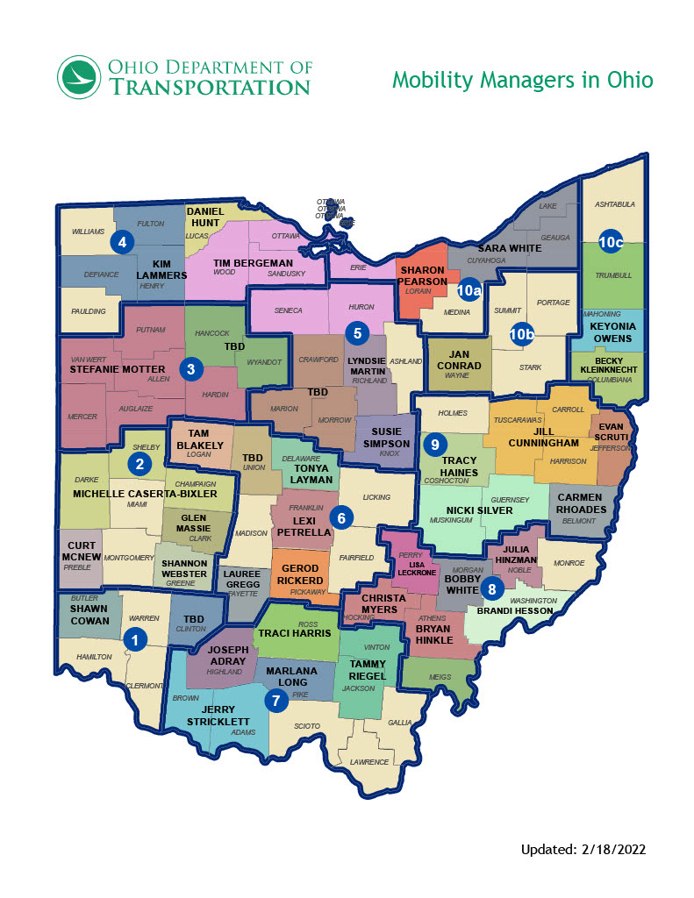
Helping coordinate and advocate for transportation services for the residents of Crawford, Marion, and Morrow Counties.

With public input, a regional transportation plan was created for Crawford, Marion and Morrow Counties. In addition to statistical data, the plan includes both regional and county-specific goals.
The Mobility Management project uses this plan as a guide to ensure that we are all working together towards meeting the regional and local goals that were set therein.

The Plan Includes:
- Regional Transportation Goals
- Goals for Crawford County
- Goals for Marion County
- Goals for Morrow County The plan is reviewed annually and
updated as needed. Contact us if you are interested in being a part of the annual plan review.

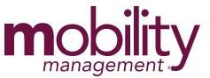
Funded By:
Mobility Management projects are supported by grants through the Federal Transit Authority (FTA) and/or the Ohio Department of Transportation (ODOT) to help communities coordinate and maximize transportation options.

Types of Services Offered
Mobility Management comes in many forms and each is unique, just like the local communities that they serve. The CMM Mobility Management project is involved in things such as, but not limited to:
- Coordination of Transit Services

- Eligibility/Referrals for Clients

- Driver Training & Call Center

- Travel Training Services

- Safe Routes to School

- Complete Streets & Active Transportation

- Local/Regional Transportation Roundtables

- Community Education & Public Outreach

Mobility Management is an approach to designing and delivering transportation services that starts and ends with the customer. It begins with a community vision in which the entire transportation network (public/private transit operators, cycling, and walking) works together with customers, planners, and stakeholders to deliver the transportation options that best meet the community’s needs.

“Mobility Management focuses on moving people by utilizing all mobility service and options within a community.”

Mobility Management:
- Encourages innovation and
flexibility to reach the “right fit” solution for customers/residents
- Plans for sustainability
- Strives for easy information and referral to assist customers in learning about and using services
- Continually incorporates customer feedback as services are evaluated and adjusted

We Are Here for You
Reach out and contact us whenever any form of mobility is in question CMM Mobility Management is here to serve and assist you!

Counties Being Served
This mobility management project is serving residents and agencies in:
- Crawford
- Marion
- Morrow

For all Title VI and/or ADA complaints please contact Executive Director Sundie Brown at 419-949-2603. Copies of these policies are located on our website at CMMMobility.org.
For general issues or concerns please contact the Mobility Manager at 419-949-2603.
This brochure can be made available in alternate formats upon request.

